**SQL PROJECT – EMPLOYEE INFORMATION**

1. **select * from Employee_info;**

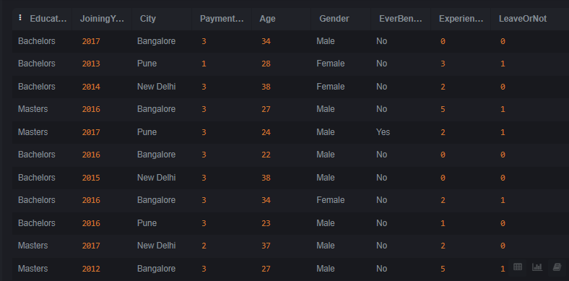

1. **SELECT Education, COUNT(*) AS Count FROM Employee_info GROUP BY Education;**

1. **SELECT City, AVG(Age) AS AvgAge, AVG(ExperienceInCurrentDomain) AS AvgExperience FROM Employee_info GROUP BY City;**

1. **SELECT COUNT(*) AS Count FROM Employee_info WHERE EverBenched = 'Yes' AND LeaveOrNot = 1;**

1. **SELECT DISTINCT PaymentTier FROM Employee_info;**

1. **SELECT MAX(Age) AS MaxAge, MIN(ExperienceInCurrentDomain) AS MinExperience FROM Employee_info;**

1. **SELECT City, Gender, AVG(Age) AS AvgAge FROM Employee_info GROUP BY City, Gender; A screenshot of a computer

   Description automatically generated**
2. **SELECT * FROM Employee_info WHERE Education = 'PHD';**

1. **SELECT Education, AVG(Age) AS AvgAge FROM Employee_info GROUP BY Education;**

1. **SELECT Gender, COUNT(*) AS Count FROM Employee_info GROUP BY Gender;**

1. **SELECT * FROM Employee_info WHERE PaymentTier = 3 AND ExperienceInCurrentDomain > 3;**

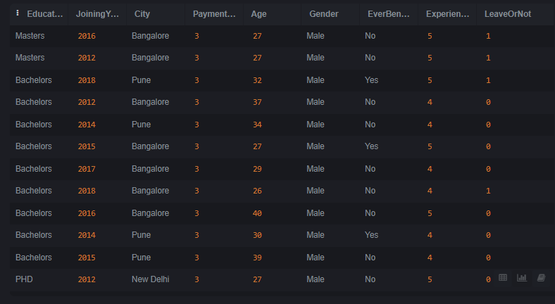

1. **SELECT EverBenched, AVG(Age) AS AvgAge FROM Employee_info GROUP BY EverBenched;**

1. **SELECT * FROM Employee_info WHERE LeaveOrNot = 1 AND PaymentTier = 2;**

1. **SELECT City, MAX(ExperienceInCurrentDomain) AS MaxExperience FROM Employee_info GROUP BY City;**

1. **SELECT Education, Gender, AVG(Age) AS AvgAge FROM Employee_info GROUP BY Education, Gender; A screenshot of a computer

   Description automatically generated**
2. **SELECT * FROM Employee_info WHERE Education = 'PHD' AND PaymentTier = 3; A screenshot of a computer

   Description automatically generated**
3. **SELECT Gender, AVG(ExperienceInCurrentDomain) AS AvgExperience FROM Employee_info GROUP BY Gender;**

1. **SELECT * FROM Employee_info WHERE Education = 'Masters' AND JoiningYear < 2015;**

1. **SELECT Education, City, COUNT(*) AS Count FROM Employee_info GROUP BY Education, City; A screenshot of a computer

   Description automatically generated**
2. **SELECT AVG(Age) AS AvgAge FROM Employee_info WHERE Education = 'PHD' AND LeaveOrNot = 1; A screenshot of a computer

   Description automatically generated**